Pandora’s Ted E Bear  Gold/Apricot F1B Goldendoodle  Curly, 28lbs | Utopia Noah D’Gethen  Red Poodle  PD03959710 (AKC) | Utopia Sunset Cain  Parti Poodle  PD03922151 (AKC) | Little P.P. Man  Poodle
Baotie
Poodle
 |  | Terragethen Vesna  Poodle  PD02856054 (AKC) | Terragethen Petey  Poodle
Terragethen Layla
Poodle
 | Hilltop Pup’s Pandora  Apricot F1  Flat Coat | Silvermine Titan King of Titans  European Golden Retriever  SR60134608 (AKC) | Rhett of Wolf Point  Golden Retriever
De Helvet Can Tatiana
Golden Retriever
 |  | Hilltop Pup’s Suzie  Poodle | Gaston’s Poppi  Poodle
Kit-Sue’s Phantom Filly Lizzie
Poodle
GDA’s Luna Of RSF  Apricot Parti Goldendoodle  Straight, 28lbs | GDA’s Schommers Cooper  CHIP 981020011136928  Blonde Parti | GDA’s Schommers Chips For A Parti, Cream Goldendoodle | Quest’s Search For Romance Parti Poodle
 |  |  | Goldenquest’s Keeping Faith Golden Retriever
 |  | GDA’s Schommer’s Jasmine  Cream Goldendoodle | GDA’s Schommer’s Mac  Blonde Goldendoodle
Schommer’s Ruby Red
Red Goldendoodle
 | FarmerDoodles Kylie  CHIP 011366261  Red Goldendoodle | FarmerDoodles Simon  Parti Goldendoodle | Springview’s Titan  Red Poodle
Springview’s Aspen
Goldendoodle
 |  | FarmerDoodles Arbor  Golden Goldendoodle | Loustou’s Antares Armis In Red Poodle
Wintersky Cosmopolitan
Golden Retriever
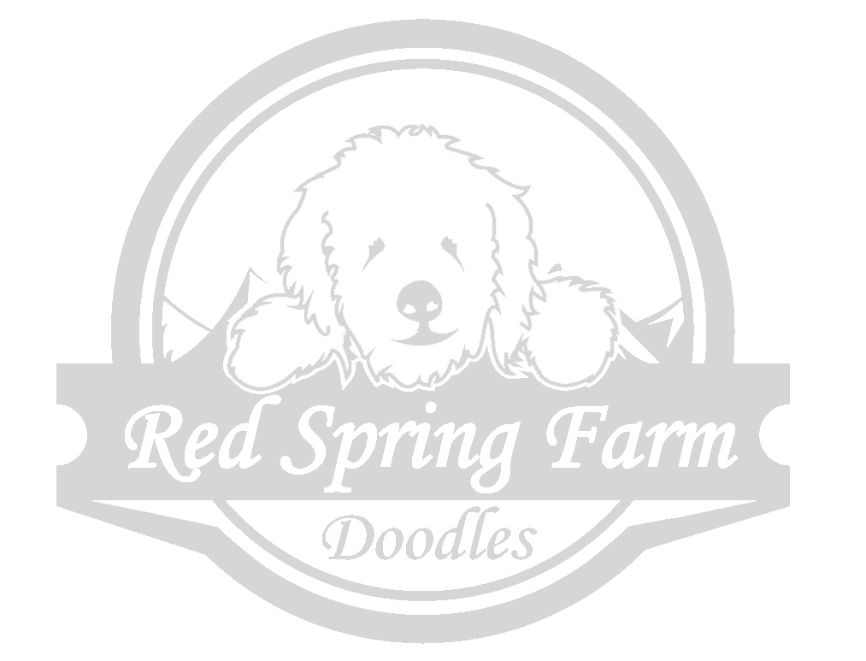
www.redspringfarm.com

