GDA’s Schommers Cooper  CHIP 981020011136928  Blonde Parti  Wavy, 25lbs, 16 Inches | GDA’s Schommers Chips For A Parti, Cream Goldendoodle | Quest’s Search For Romance Parti Poodle | Quests Glitz Plus Glamour  Red Poodle
 |  |  | Pawrieb’s Quest’s I Love Lucy, Red Poodle
 |  | Goldenquest’s Keeping Faith Golden Retriever | Int Ch Sunbeams A Wink and A Smile CD
 |  |  | Laurell’s Early May Delight
 | GDA’s Schommer’s Jasmine  Cream Goldendoodle | GDA’s Schommer’s Mac  Blonde Goldendoodle | GDA’s Schommer’s Dakota Lightning, Poodle
Dennis Sparkling Chablis
Golden Retriever
 |  | Schommer’s Ruby Red  Red Goldendoodle | Quest’s Gentle Genisis  Goldendoodle
Quest Snow Angel
Poodle
FarmerDoodles Kylie  CHIP 011366261  Red Goldendoodle  Wavy, 20lbs, 15 Inches | FarmerDoodles Simon  Parti Goldendoodle | Springview’s Titan  Red Poodle | Loves Lucy  Poodle
 |  |  | Poodle- unverified
 |  | Springview’s Aspen  Goldendoodle | Sarkey of Sanitacteam Day, Golden Retriever
Solo Daisy Mae
Poodle
 | FarmerDoodles Arbor  Golden Goldendoodle | Loustou’s Antares Armis In Red Poodle | Sherfames Red Hot Tip
 |  |  | Simply Red;s Sophia Mama Mia
 |  | Wintersky Cosmopolitan  Golden Retriever | Topper Topbrass of BDK
 |  |  | Autumnsun Jesse
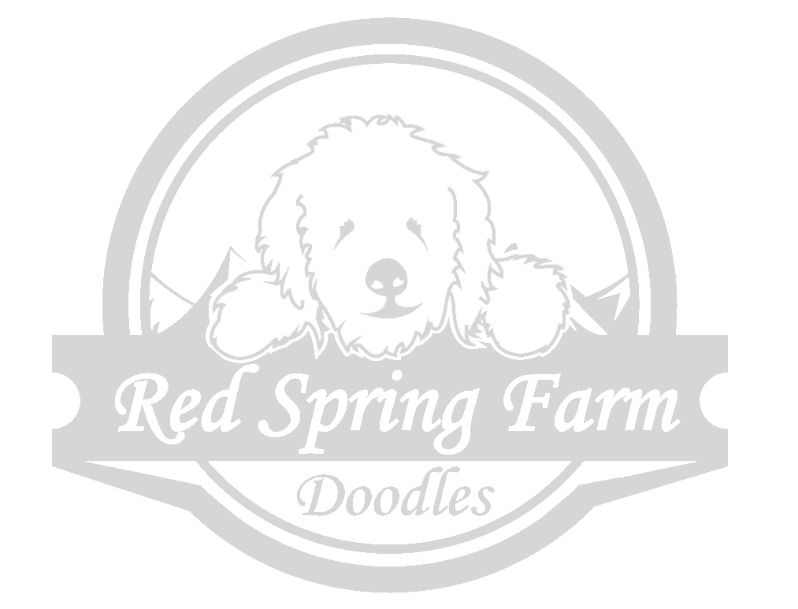
www.redspringfarm.com

