MSR’s Under The Sea  PR18851102 (AKC)  Red Poodle  Curly, 15lbs | KC Little Red Run Run Rudolph PR15303906 | Idaho Jewels Red Cherokee Hawk  Poodle | Rainbow’s Bright Copper Cork  Poodle
Rainbow’s Penny From Heaven
Poodle
 |  | Sammi’s Spitin Image RLD  Poodle | Sweet Sammi Red Sunset RLD  Poodle
Idaho Jewels Red Cherry Flambe’
Poodle
 | Frankly My Dear Scarlett RLD PR14641801 | Flaming Skittles  Poodle | Justice Red Hot Zephyr  Poodle
Serafina Flaming Desire
Poodle
 |  | L’il Ariel’s Sunshine Dance  Poodle | Rosaline’s Autumn Sunshine Fabio, Poodle
Sienna’s Sundance Impact
Poodle
Safari’s This Girl Is On Fire NOREG1663015  Red Goldendoodle  Wavy, 30lbs | Ruff N Tuff Scrappy Doo PR09984301 (AKC)  Poodle | Cameo’s Ruby Jeweled Hawk, PR05517701 | Ch Elusive Toys The Kwon Do
 |  |  | Cherubs Hearts On Fire
 |  | Windycity’s I Lpve Lucy, PR03504003 | Cerenau Royal Flam
 |  |  | Windair’s Red Head
 | Red-Dawn Greer Garson | Rockerin Red River Ruckus MH | FC AFC Glenhaven HTRS MN Baronet MH
 |  |  | Cedarponds Rockerin Beabhin
 |  | Green Acres Sweetheart Pumpkin Pie  SR44422210 (AKC) | Murphy’s Pride IV, SR07844305
 |  |  | Katy Rose Roulette, SR21888405
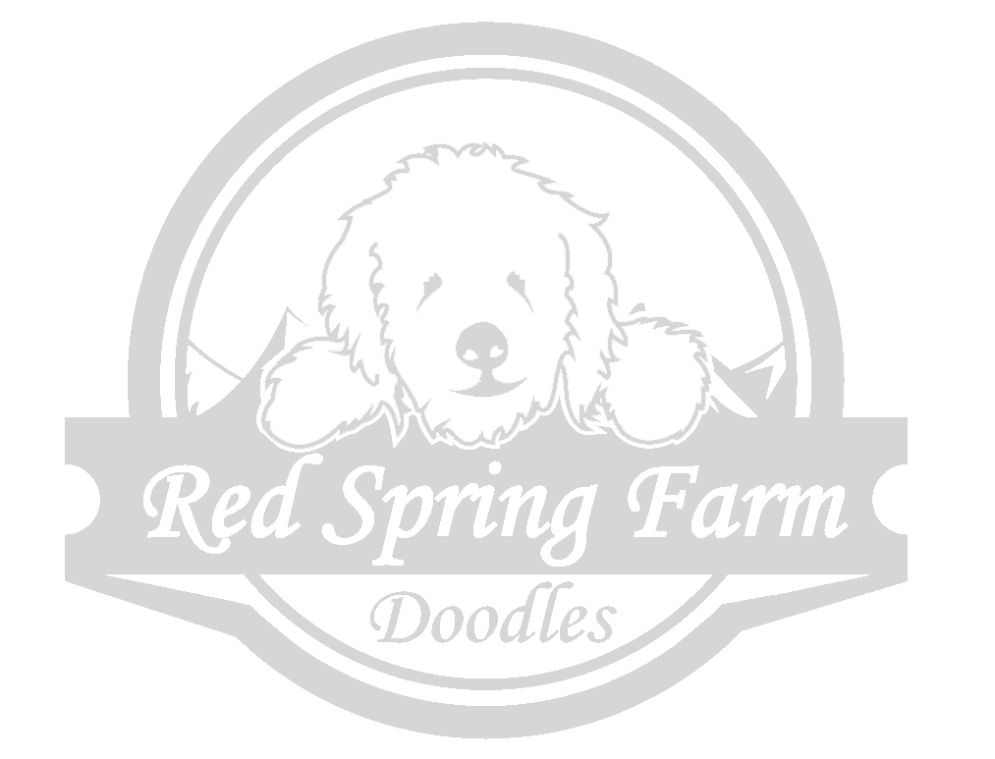
www.redspringfarm.com

